Matrix Clock Connections

- MX matrix for Arduino Mega
  - CLK_PIN 52 on Arduino
  - DATA_PIN 51
  - CS_PIN 53
  - Vin 5 v
  - GND
- 2nd MX matrix (See notes below – one of three optional 2ndary time display options)
  - CLK is also 52, don’t ‘chain’ it off primary display – connect both displays directly
  - DATA (DIN) also Pin 51, but again – connect directly, not chained
  - Vin
  - GND
  - CS_PIN 49 – each display gets its own CS
- FX Sound Board
  - Vin 5v
  - GND
  - ACT Pin to Arduino Pin 8
  - Sound Board Pins 0-9 to Arduino Pins 30-39
  - Speaker outputs to 8 ohm speaker
- MPL115A2 Barometer
  - GND
  - Vin 5v
  - SDA on Arduino
  - SCL - same
- RTC DS3231
  - GND
  - Vin 5V
  - SDA on Arduino
  - SCL on Arduino
- Push Buttons for Set, Up, Down and Demo mode (SPST Momentary)
  - One side of each switch to GND
  - PB1 = Set, to Arduino pin 2
  - PB2 = Up, to pin 3
  - PB3 = Down, to pin 4
  - PB4 = Demo to pin 7
- Automatic Shutoff at Nite (ANSO) toggle switch (SPST)
  - One side to GND
  - One side to Arduino pin 10
- Wifi / NTP time switch – toggle switch (SPST)
  - One side to GND
  - One side to Arduino pin 11
- Westminster/Chime toggle switch (SPDT Center Off)
  - Center connection to GND
  - Upper connection (Westminster) to Pin 5
  - Lower connection (Bell only) to Pin 6
  - Sounds loaded onto FX SoundBoard in OGG format
    - T0 – Short single Westminster Chime
    - T1 – Westminster 15 minute
    - T2 – Westminster 30 minute
    - T3 – Westminster 45 minute
    - T4 – Westminster hour
    - T5 – Trailing (longer) Westminster Chime – plays last in sequence
    - T6 – Short Single bell chime
    - T7 – Trailing (longer) single bell chime – plays last
    - T8 – Boot up sound (plays when powered up to signal sound is working TaDA sound)
    - T9 – Game of Thrones theme to play during Easter Egg Display

- LDR photocell (see diagram)
  - GND
  - Vin 5v
  - Pin A0
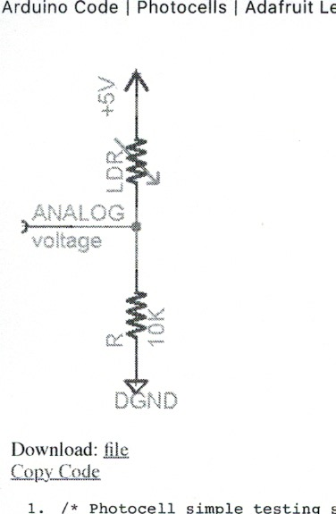

- DHT 11 or 22
  - Pin 4 to GND
  - Pin 1 to 5 Vin
  - Pin 2 (Sensor pin) to Arduino pin 9 AND to Vin (or Pin 1) through 10K resistor
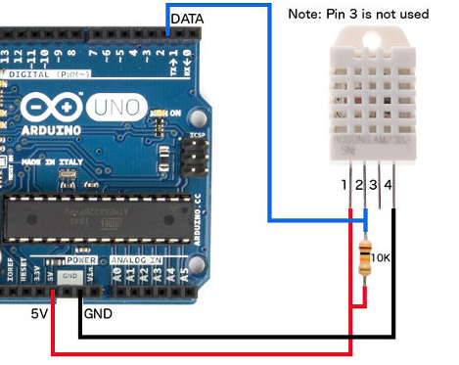

- Co-Processor (ESP 8266)
  - Vin 5v
  - GND
  - ESP8266 Pin D4 [IDE alias pin 2] To Arduino Pin 23 (polling pin)
  - ESP8266 Pin D2 [IDE alias pin 4] To Arduino SDA
  - ESP8266 Pin D1 [IDE alias pin 5] To Arduino SCL
- If using four 8x8 independent matrix displays instead of 2nd MX7219
  - Ensure each of the four has a different I2C address
  - Connect all to Vin 5v and GND
  - Connect each to the Arduino SDA and SCL pins
- If using a four segment numeric LED (e.g. 1.2” display) with IC2 backpack instead
  - Connect to both V0 and Vin to 5v Vin
  - Connect GND to GND
  - Connect SDA to Arduino SDA
  - Connect SDL to Arduino SDL
- Power
  - Use 4-5 amp power adapter with 5v output
  - Create a bus for + and –
  - Connect all Vin 5V to the + side of bus
  - Connect All GND to – side of bus
  - Connect Arduino Mega Vin and GND to the bus as well (in other words, don’t power anything through the Arduino)

